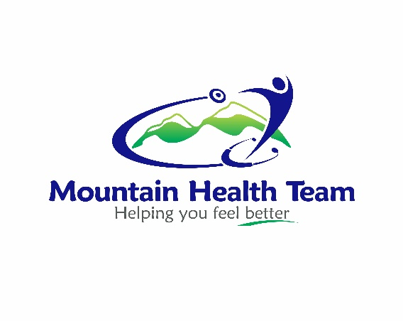

Mountain Health Team ND Locum Associateship Application 2021
Dear Applicant,
Are you looking for a change or to brush up on your naturopathic primary care skills? The Mountain Health Team is searching for an entrepreneurial minded ND that is passionate about using a broad scope of practice. We are a multi-disciplinary team of practitioners made up of Naturopathic Doctors, Massage Therapists, Midwives, a Certified Childbirth Educator and Lactation Educator and a Counsellor. The clinic is located in the growing city of Airdrie which is 20 minutes north of Calgary and also surrounded by several small towns and a large rural community.
Associateship
This is approximately a 6 to 10 month term to cover the maternity leave of Dr. Mountain's Associate. Although experienced ND's are welcome to apply, Dr. Mountain has developed a syllabus designed to provide new graduates with an opportunity for clinical guidance in Naturopathic Primary Care with a focus on professional business mentorship. Before becoming an ND, Dr. Mountain worked for nearly 10 years in management and corporate training and he has a passion for preparing ND’s for a successful naturopathic business. Dr. Mountain believes that Residency training is also important to extend the quality of Naturopathic Medical education and enhance the credibility of the profession for the mainstream population.
Associateship Compensation
The remuneration is negotiable and could be salary, percent split of patient revenues or combination.
Application Deadline and Process
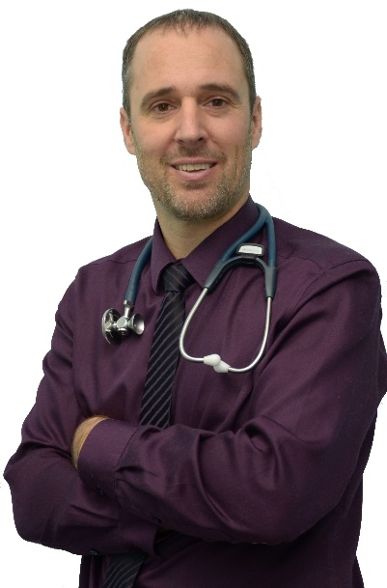
December 21st, 2020 is the final deadline, but this posting may close beforehand if a suitable candidate is found. Please email the Application Form (below) with a Cover Letter and Resume attached together to begin your process.
Thank-you for your interest in our Associateship opportunity and all the best!
Please send your completed application to:
Dr. Richard Mountain, BSc, CSEP-CEP, ND.
rmountain@mountainhealthteam.com

Mountain Health Team Associateship Application 2021

Please Type in the fields below:

Name: ________________________________________________________________________
(First) (Middle) (Last)
Please attach a picture of yourself as you would like to appear to patients:
Insert your picture in this space

My Naturopathic Doctor degree/diploma is from:
- The Canadian College of Naturopathic Medicine
- Boucher Institute of Naturopathic Medicine
- Bastyr University
- National University of Natural Medicine
- National University of Health Sciences
- University of Bridgeport College of Naturopathic Medicine
- Southwest College of Naturopathic Medicine

Month and Year you graduated:

Your Address: _______________________________________________________________
(Street) (City)
_______________________________________________________________
(Prov/State) (Postal Code/ZIP)
Phone: ( )______________________ Email: ________________________

Mountain Health Team Associateship Application 2021
Please answer the following questions:
- Why did you choose to be a Naturopathic Doctor?

- Which patient population do you like to work with the best?

- Where do you see yourself professionally in 2 years?

- What was the most challenging aspect of Naturopathic School?

- Do you have, or immediately plan to get, your IV Certification? Yes No

- Which common modality in Naturopathic Medicine do you have the least experience with?

- What percentage of working time do you think a new ND associate should spend on each of the following:
  - Patient appointments: _______%
  - Reviewing labs and patient research: _______%
  - Administrative (supplies, checking inventory, bookkeeping…): _______%
  - Marketing (talks, networking, social media…): _______%
  - Continuing education: _______%
Total: 100 %

